Lesson Summary
- On a number line, arrows are used to represent integers; they show length and direction.
- The length of an arrow on the number line is the absolute value of the integer.
- Adding several arrows is the same as combining integers in the Integer Game.
- The sum of several arrows is the final position of the last arrow.
Homework: Unit 2 Lesson 2
- David and Victoria are playing the Integer Card Game. David drew three cards, $-6$, $12$, and $-4$. What is the sum of the cards in his hand? Model your answer on the number line below.
- If a football player gains $40$ yards on a play, but on the next play, he loses $10$ yards, what would his total yards be for the game if he ran for another $60$ yards? What did you count by to label the units on your number line?
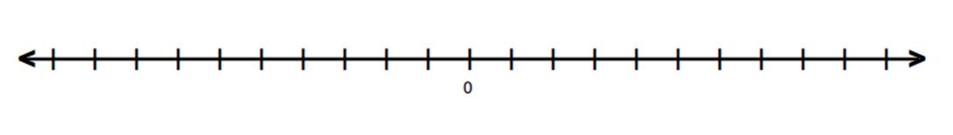
- Find the sums.
  - $-2+9$ = ________
  - $-4+(-6)+10$ = ____________

- Write a story problem that would model the sum of the arrows in the number diagram below.

