Lesson 7: Addition and Subtraction of Rational Numbers

Classwork

Exercise 1: Real-World Connection to Adding and Subtracting Rational Numbers

Suppose aseventh grader’s birthday is today, and she is $12$ years old. How old was she $3\frac{1}{2}$ years ago? Write an equation, and use a number line to model your answer.

Example 1: Representing Sums of Rational Numbers on a Number Line

1. Place the tail of the arrow on $12$.
2. The length of the arrow is the absolute value of $-3\frac{1}{2}$. **NOTE: $\left|-3\frac{1}{2}\right|=3\frac{1}{2}$** .
3. The direction of the arrow is to the *left* since you are adding a negative number to $12$.

Draw the number line model in the space below.

Exercise 2

Find the following sum using a number line diagram: $-2\frac{1}{2} + 5$.

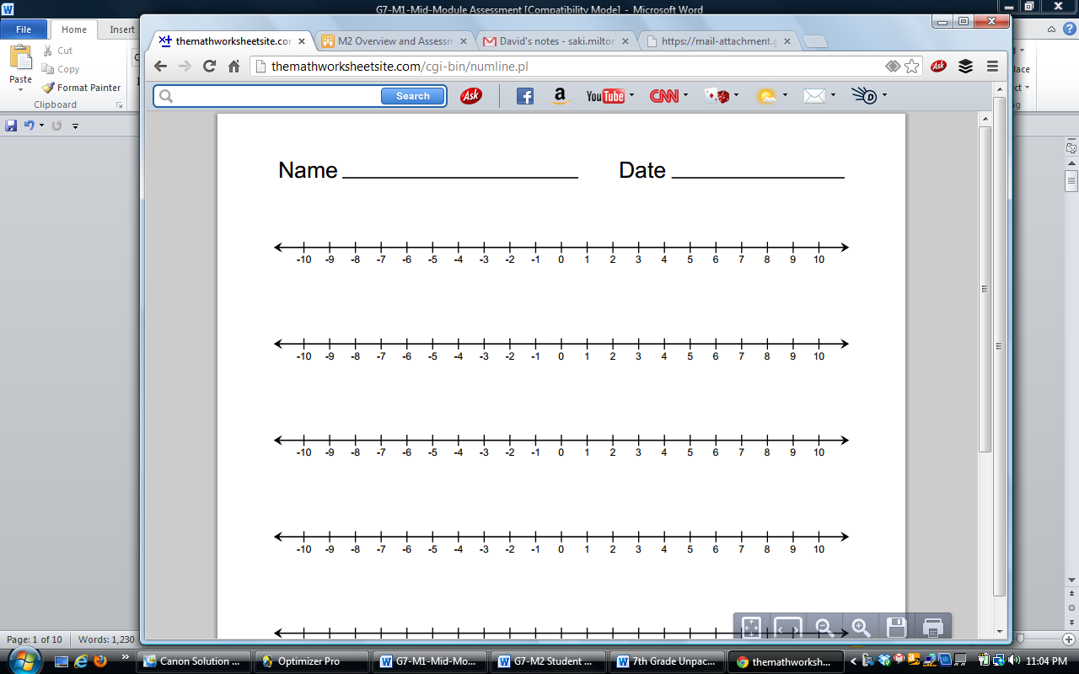

Example 2: Representing Differences of Rational Numbers on a Number Line

Find the following difference, and represent it on a number line: $1-2\frac{1}{4}$.



Now follow the steps to represent the sum:



Draw the number line model in the space below.

Exercise 3

Find the following difference, and represent it on a number line: $-5\frac{1}{2}-(-8)$.



Exercise 4

Find the following sums and differences using a number line model.



$-6+5\frac{1}{4}$

$7-(-0.9)$

$\frac{1}{2}-\left(-3\right)$

Exercise 5

Create an equation and number line diagram to model each answer.

1. Samantha owes her father $\$7$. She just got paid $\$5.50$ for babysitting. If she gives that money to her dad, how much will she still owe him?
2. At the start of a trip, a car’s gas tank contains $12$ gallons of gasoline. During the trip, the car consumes $10\frac{1}{8}$ gallons of gasoline. How much gasoline is left in the tank?
3. A fish was swimming $3\frac{1}{2}$ feet below the water’s surface at 7:00 a.m. Four hours later, the fish was at a depth that is $5\frac{1}{4}$ feet below where it was at 7:00 a.m. What rational number represents the position of the fish with respect to the water’s surface at11:00 a.m.?

