Lesson 9: Solving Equations Using Algebra

Classwork
Exercises
- Youth Group Trip
The youth group is going on a trip to an amusement park in another part of the state. The trip costs each group member $\$150$, which includes $\$85$ for the hotel and two one-day combination entrance and meal plan passes.
  - Write an equation representing the cost of the trip. Let $P$ be the cost of the park pass.

  - Solve the equation algebraically to find the cost of the park pass. Then write the reason that justifies each step using if-then statements.

  - Model the problem using a tape diagram to check your work.

Suppose you want to buy your favorite ice cream bar while at the amusement park and it costs $\$2.89$. If you purchase the ice cream bar and $3$ bottles of water, pay with a $\$10$ bill, and receive no change, then how much did each bottle of water cost?
  - Write an equation to model this situation.

  - Solve the equation to determine the cost of one water bottle. Then write the reason that justifies each step using if-then statements.

  - Model the problem using a tape diagram to check your work.

- Weekly Allowance
Charlotte receives a weekly allowance from her parents. She spent half of this week’s allowance at the movies, but earned an additional $\$4$ for performing extra chores. If she did not spend any additional money and finished the week with $\$12$, what is Charlotte’s weekly allowance?

  - Write an equation that can be used to find the original amount of Charlotte’s weekly allowance. Let $A$ be the value of Charlotte’s original weekly allowance.

  - Solve the equation to find the original amount of allowance. Then write the reason that justifies each step using if-then statements.

  - Explain your answer in the context of this problem.

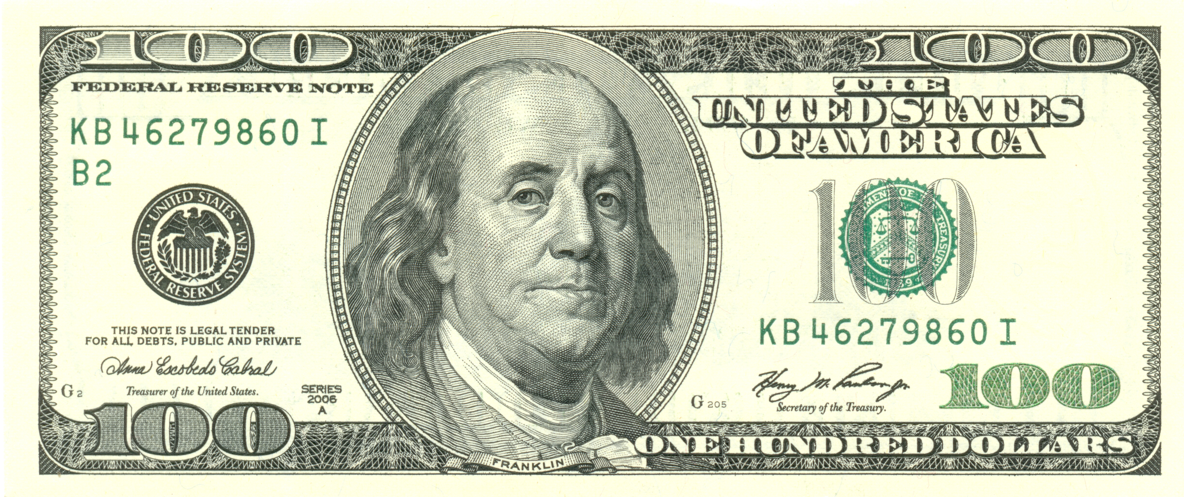
  - Charlotte’s goal is to save $\$100$ for her beach trip at the end of the summer. Use the amount of weekly allowance you found in part (c) to write an equation to determine the number of weeks that Charlotte must work to meet her goal. Let $w$ represent the number of weeks.

  - In looking at your answer to part (d) and based on the story above, do you think it will take Charlotte that many weeks to meet her goal? Why or why not?

- Travel Baseball Team
Allen is very excited about joining a travel baseball team for the fall season. He wants to determine how much money he should save to pay for the expenses related to this new team. Players are required to pay for uniforms, travel expenses, and meals.
If Allen buys $4$ uniform shirts at one time, he gets a $\$10.00$ discount so that the total cost of $4$ shirts would be $\$44$.

  - Write an algebraic equation that represents the regular price of one shirt. Solve the equation. Write the reason that justifies each step using if-then statements.

  - What is the cost of one shirt without the discount?

  - What is the cost of one shirt with the discount?

  - How much more do you pay per shirt if you buy them one at a time (rather than in bulk)?

Allen’s team was also required to buy two pairs of uniform pants and two baseball caps, which total $\$68$. A pair of pants costs $\$12$ more than a baseball cap.
  - Write an equation that models this situation. Let $c$ represent the cost of a baseball cap.

  - Solve the equation algebraically to find the cost of a baseball cap. Write the reason that justifies each step using if-then statements.

  - Model the problem using a tape diagram in order to check your work from part (f).

  - What is the cost of one cap?

  - What is the cost of one pair of pants?

Lesson Summary
Equations are useful to model and solve real-world problems. The steps taken to solve an algebraic equation are the same steps used in an arithmetic solution.

Homework: Unit 3 Lesson 9

For Exercises 1–4, solve each equation algebraically using if-then statements to justify your steps.
- $\frac{2}{3}x-4=20$

- $4=\frac{-1+x}{2}$

- $12\left(x+9\right)=-108$

- $5x + 14 = -7$

For Exercises 5–6, write an equation to represent each word problem. Solve the equation showing the steps and then state the value of the variable in the context of the situation.

- A plumber has a very long piece of pipe that is used to run city water parallel to a major roadway. The pipe is cut into two sections. One section of pipe is $12$ $ft.$ shorter than the other. If $\frac{3}{4}$ of the length of the shorter pipe is $120 ft.,$ how long is the longer piece of the pipe?

- Bob’s monthly phone bill is made up of a $\$10$ fee plus $\$0.05$ per minute. Bob’s phone bill for July was $\$22$. Write an equation to model the situation using$m$to represent the number of minutes. Solve the equation to determine the number of phone minutes Bob used in July.

